Particle 2D
(Particle 2D Editor)

Introduction
What Is Particle 2D Editor

Particle 2D Editor is a tool for design our animation 2D

What We Need?

Only we need execute Gdx runnable for create our project and check
tools(Extensions)

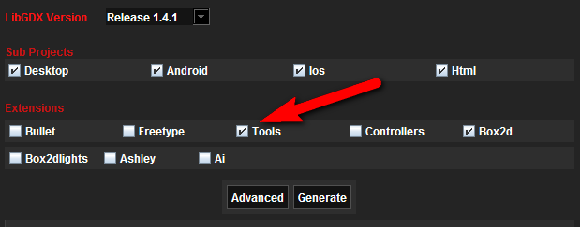
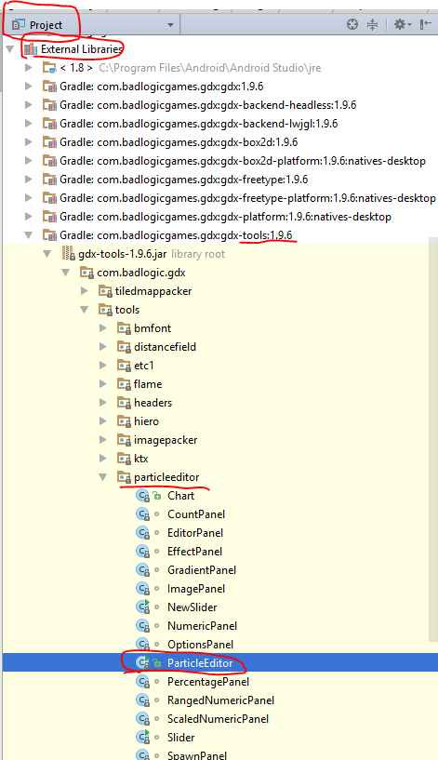
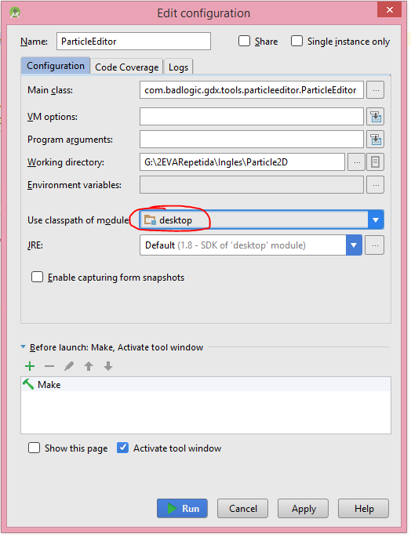

bASIC IMPLEMENTATION
First Steps
- Step 1: Create a object instance and initialize
Private ParticleEffect particle = new ParticleEffect();

- Step 2: Load the ParticleEffect in show() method
particle.load(
Gdx.files.internal(“ParticleFileName”),Gdx.files.internal(“”));

- Step 3: Positioning ParticleEffect and start it in show() method
particle.getEmitters.first.setPosition(
Gdx.graphics.getWidth() / 2,Gdx.graphics.getHeight() / 2);
particle.start();

- Step 4: Drawing the ParticleEffect
particle.update(delta);
batch.begin();
particle.draw(batch);
batch.end;

